**Electronic system task**

**Arm Slave**

**Components used:**

* **Raspberry Pi Pico (SC0915)**

The inputs from the encoders are received by the Pico and then they are sent to the Teensy for computation, via the STM32 blue pill (I2C).

A raspberry Pico has been used here mainly due to its high quality, low cost and high availability; to reduce the load on the STM32.

* **STM32F103C8T6 (blue pill)**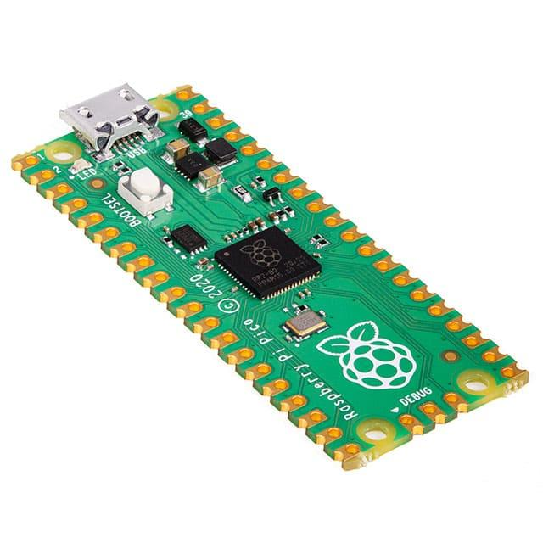

This microcontroller controls 3 motor drivers and also sends the encoder inputs to the Teensy using CAN. The PB7 and PB6 pins are being used as the SDA and SCL pins respectively for I2C communication with the Pico.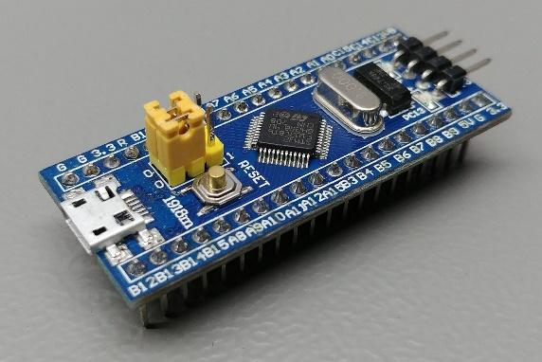

An STM32 is best suited for this role because it supports both I2C communication (Pico) and CAN (for communication with the Teensy). It also has a large number of both GPIO and PWM pins, which is essential for managing all the tasks (3 motor drivers and communication with 2 other micro-controllers) which the STM is performing.

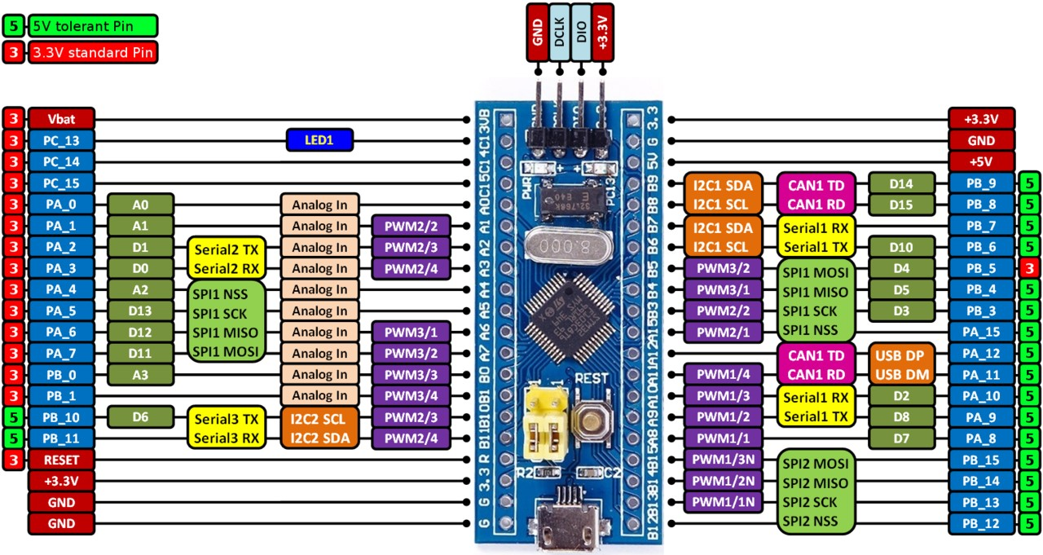

* **STMicroelectronics Motor Drivers (VNH5019ATR-E)**

The VHN5019A-E is a full bridge motor driver

intended for a wide range of automotive applications. The device incorporates dual monolithic high-side drivers and two low-side switches.

It contains an automotive fully integrated H-bridge for powering one bi-directional motor. Out of the 6 total degrees of freedom, 3 motors are controlled by the arm slave and the other 3 are controlled by the arm master. 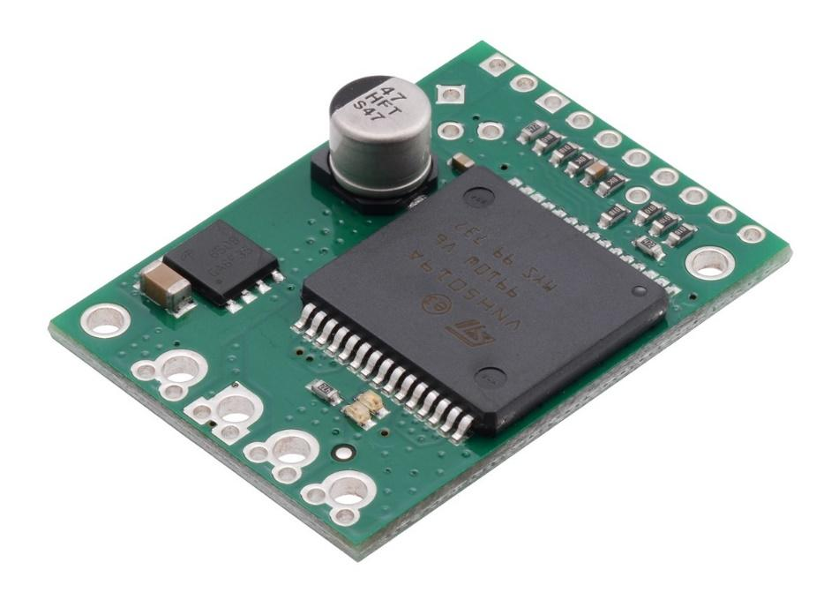

Connections:

* The input signals INA and INB can directly interface the microcontroller to select the motor direction and the brake condition.
* The DIAGA/ENA or DIAGB/ENB, when connected to an external pull-up resistor, enables one leg of the bridge.
* The PWM, up to 20 KHz, lets us control the speed of the motor in all possible conditions.

Protections:

* The DIAGA/ENA or DIAGB/ENB provides a feedback digital diagnostic signal.
* The CS pin allows to monitor the motor current by delivering a current proportional to its value when CS_DIS pin is driven low or left open.
* In all cases, a low-level state on the PWM pin turns off both the LSA and LSB switches. When PWM rises to a high-level, LSA or LSB turns on again depending on the input pin state.
* Output current limitation and thermal shutdown protect the concerned high-side in short to ground condition. The short to battery condition is revealed by the overload detector or by thermal shutdown that latches off the relevant low-side.
* Active VCC pin voltage clamp protects the device against low energy spikes in all configurations for the motor.
* The CP pin provides the necessary gate drive for an external N-channel PowerMOS used for reverse polarity protection.

Absolute maximum ratings:

| **Symbol** | **Parameter** | **Value** | **Unit** |
| --- | --- | --- | --- |
| VBAT | Maximum battery voltage | -16  +41 | V  V |
| VCC | Maximum bridge supply voltage | +41 | V |
| Imax | Maximum output current (continuous) | 30 | A |
| IR | Reverse Output Current (Continuous) | -30 | A |
| IIN | Input current (INA and INB pins) | +/- 10 | mA |
| IEN | Enable input current (DIAGA/ENA and DIAGB/ENB pins) | +/- 10 | mA |
| Ipw | PWM input current | +/- 10 | mA |
| ICP | CP output current | +/- 10 | mA |
| ICS_DIS | CS_DIS input current | +/- 10 | mA |
| VCS | Current sense maximum voltage | VCC - 41  +VCC | V  V |
| VESD | Electrostatic discharge (human body model: R = 1.5 kΩ, C = 100pF | 2 | kV |
| TC | Case operating Temperature | -40 to 150 | oC |
| TSTG | Storage temperature | -55 to 150 | oC |